**EXERCISE 3**

**Brian Nguyen**

**GATEWAY COMMUNITY COLLEGE**

**CIS166**

**CARLOS RODRIGUEZ**

**02/17/2023**

**I have created a GitHub repository and have added you as an account to view my project.**

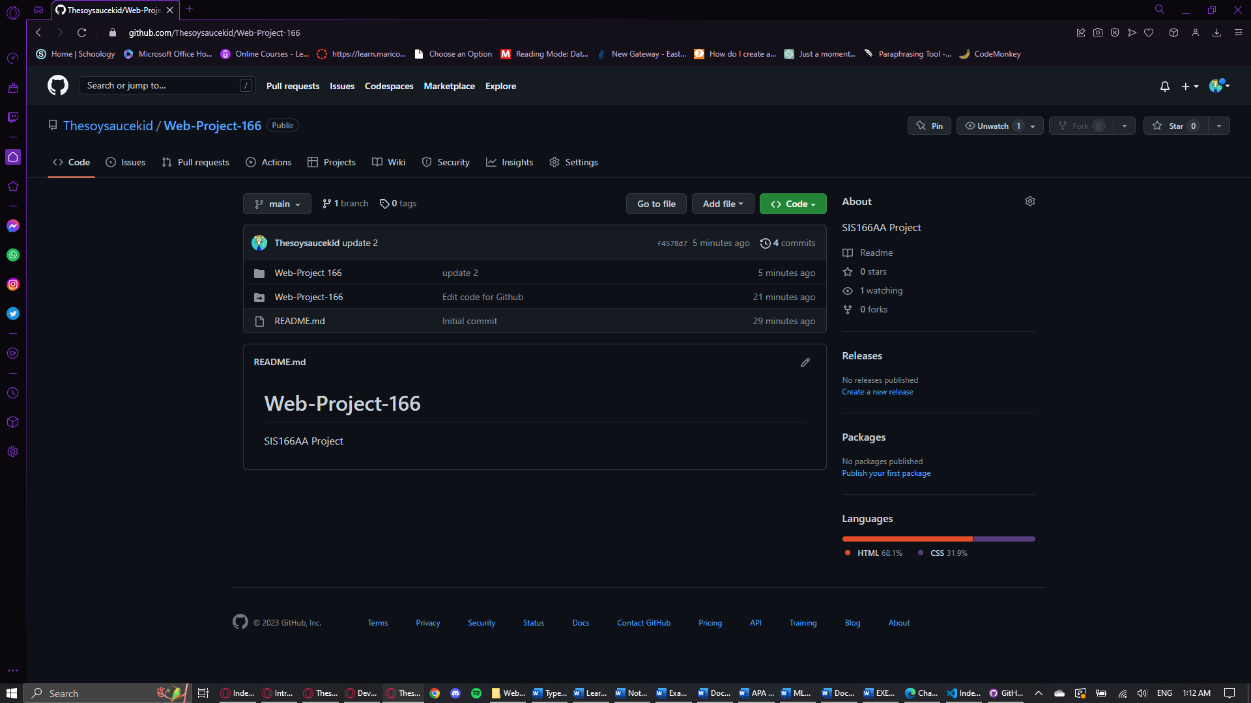

Added a Contact us email link

I added you as a collaborator.

